**Digital Image Processing**

***Submitted by: Soutrik Maiti***

***UTA ID – 1001569883***

1. *Interpolation by replication*

*MATLAB CODE:*

image = imread('goldhill256.bmp');

[r,c,x] = size(image);

N = zeros(2*r,2*c);

for i = 1:1:r

for j = 1:1:c

for k = j*2:1:(j*2+2)

N(2*i,k) = image(i,j);

end

end

end

for i = 1:2:r*2

for j = 1:1:c*2

N(i,j) = N(i+1,j);

end

end

figure(1)

imshow(image);

title('Original');

figure(3)

imshow(N,[]);

title('Zoomed')

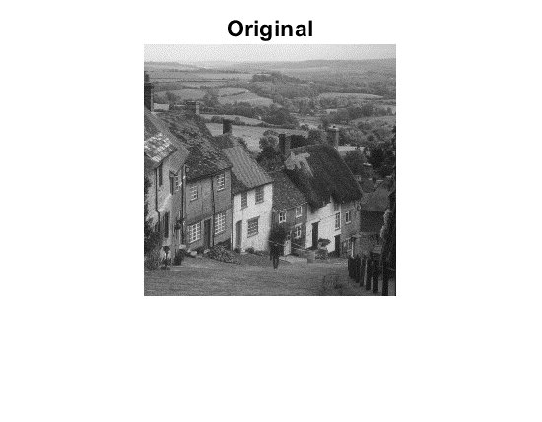

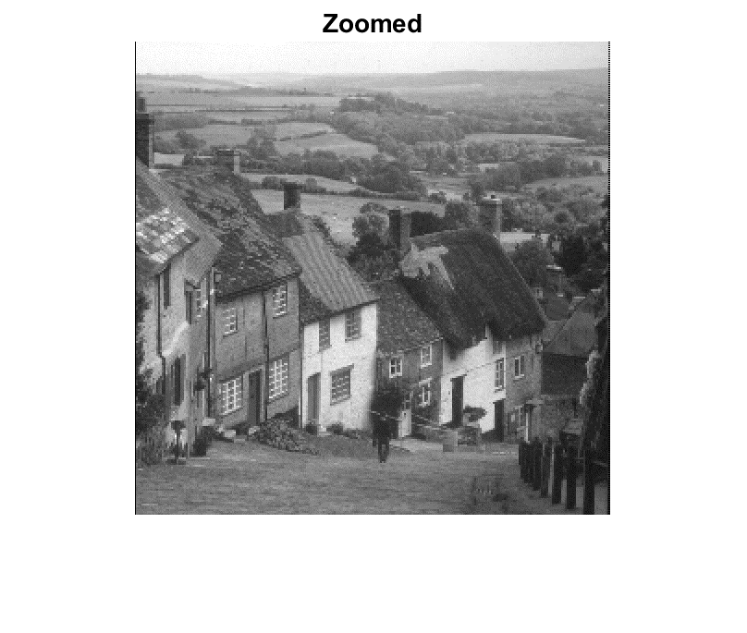

1. *Linear Interpolator*

*MATLAB CODE:*

image = imread('goldhill256.bmp');

[r,c,x] = size(image);

N = zeros(2*r,2*c);

h = [1 1;1 1];

for i = 1:1:r

for j = 1:1:c

for k = j*2:1:(j*2+2)

N(2*i,k) = image(i,j);

end

end

end

for i = 1:2:r*2

for j = 1:1:c*2

N(i,j) = N(i+1,j);

end

end

r = conv2(N,h/4,'valid');

figure(1)

imshow(image);

title('Original');

figure(3)

imshow(r,[]);

title('Zoomed')



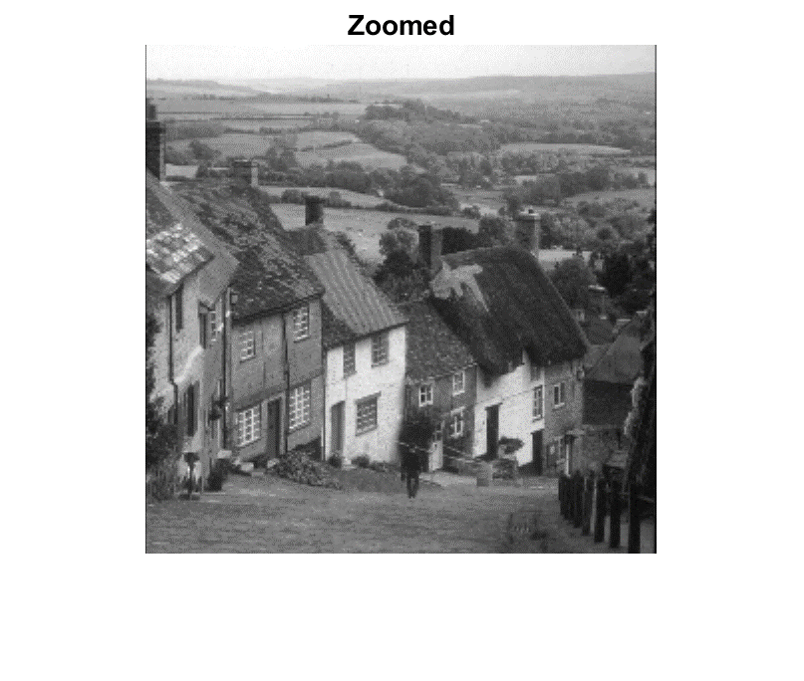

1. *Cubic Spline Interpolator*

*MATLAB CODE:*

img = imread('goldhill256.bmp');

[m,n,x] = size(img);

k = 1;

l = 1;

f = 2;

zoom = zeros(m*f,n*f);

for i = 1:m

for j = 1:n

zoom(k,l) = img(i,j);

l=l+f;

end

k=k+f;

l = 1;

end

H = [1 1;1 1];

h1 = 0.25*conv2(H,H);

h2 = 0.25*conv2(h1,H);

h3 = 0.25*conv2(h2,H);

r = conv2(zoom,h3,'valid');

figure(1);

imshow(img,[])

title('Orignal’);

figure(2)

imshow(uint8(r));

title('Zoomed');

